Install the configuration tool Dev Tool and run it

Prerequisite:

1. Check if the computer firewall is turned off, if there is a virtual network card, and if the virtual network card needs to be disabled

2. Confirm with technical personnel whether the terminal program needs to be updated

3. Connect the terminal to the internet and search

4. Confirm whether the installation environment of the terminal is in the same network segment and whether it crosses routes (such as different network segments or if it crosses routes, it needs to be configured in the network segment of the extension, otherwise it cannot be searched



Installed, search for it and modify the IP address first 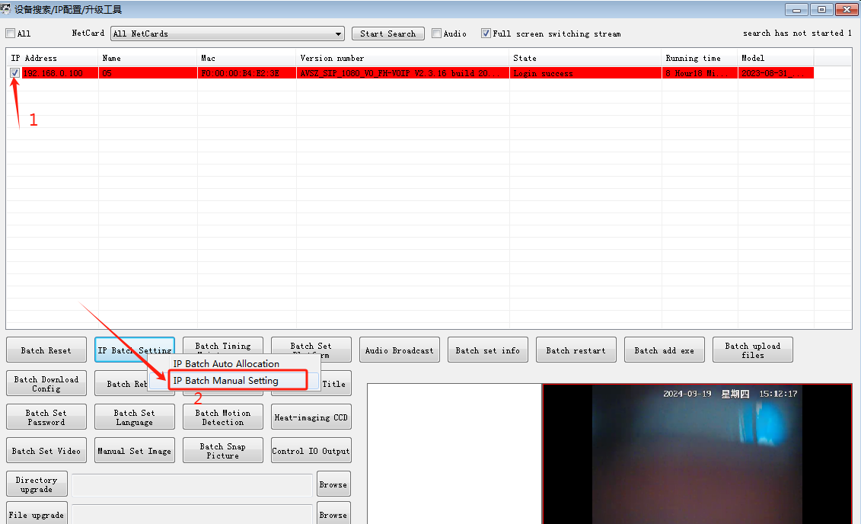

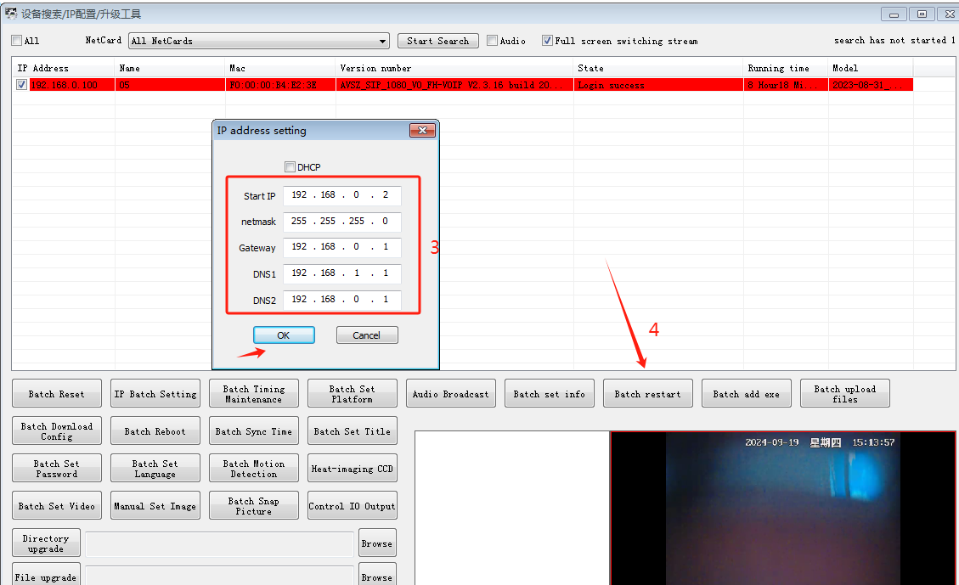

1. Select the terminal that needs to be configured, right-click: Remote Configuration, english (language can be modified according to habits)

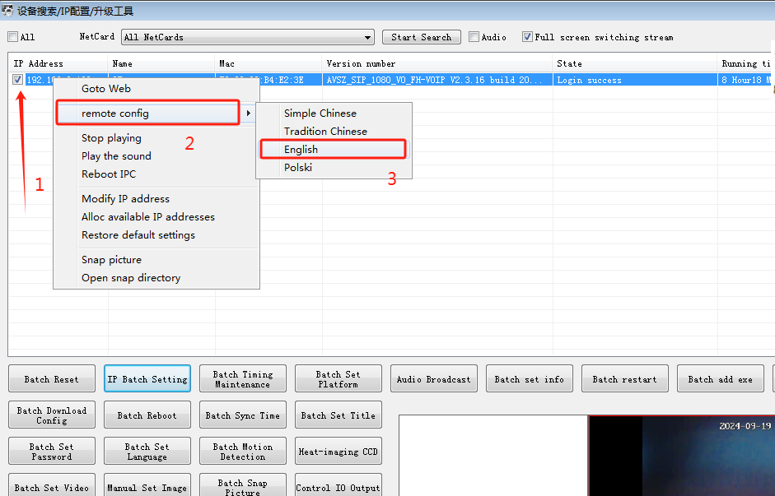

2. Network Settings - Platform Access Settings: Set up communication with SIP phone - Register successfully by logging in to the IP address and port of the SIP server, setting the access account and password, and saving them

One extension logs in to 101, while the other logs in to 102. Access server address 101102, the other one is 102101 (comma in English) 